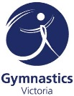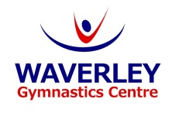+



**ABOUT OUR PROGRAM**

* Waverley Gymnastics is a 5-star Centre, as rated by Gymnastics Australia
* Junior Gym is a structured program with an emphasis on fun and learning – a program that grows with your child!
* We teach gymnastics skills that can lead to improved co-ordination, balance and confidence
* Suitable for children aged 2-5 years old (not yet attending school)
* Parent assisted classes for 2-4 year olds, and non parent assisted classes for 4-5 year olds
* All classes are led by our warm, friendly and qualified coaches and run for 50 minutes

**2022 JUNIOR GYM TIMETABLE**

We regularly add in new classes, so for more information on class availabilities, or to book in for a trial class,   
please call the office on **9887-9611**, email **juniorgym@wgc.org.au**, or visit our website at **www.wgc.org.au.**

***Waverley’s Junior Gym Program – Fun, Safe, Learning – A program that grows with your child.***

**Waverley Gymnastics Centre**

**2022 JUNIOR GYMNASTICS**